Uploading Files

Under your employee profile, there is the option to upload documents; once uploaded, these are then stored on your employee record. Your profile can be accessed from the top left-hand corner of your Employee Dashboard by clicking on the circle highlighted below that will contain either your profile picture or your initials (where no picture is available).
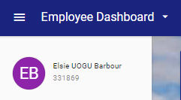

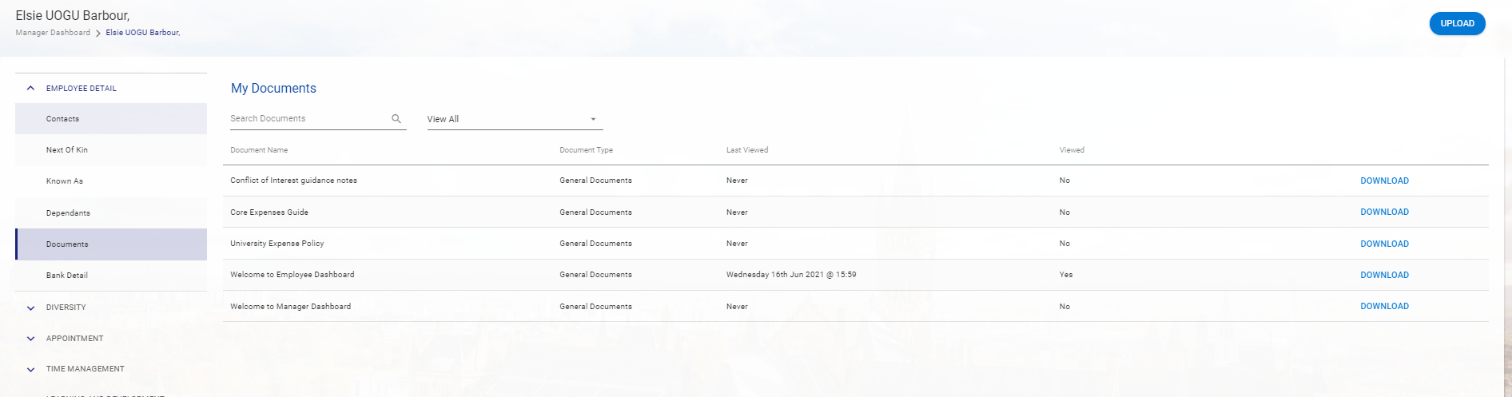
Once you’ve clicked on this circle, you’ll be directed to an area of the system where your personal details are held and can be viewed and amended. To upload a document, click on ‘Documents’ from the left-hand menu. The ‘My Documents’ screen will load.

To upload a document, click on the blue ‘Upload’ button at the top right of the screen.

The Upload Document box will appear; mandatory fields are noted with an asterisk *. Enter a title for your document and choose the Document Type ‘Uploaded by Employee’. To upload a file, select the arrow icon highlighted below next to the Document File field. You can then browse and select the correct file on your PC. Once you’ve completed the required information, click the ‘OK button.
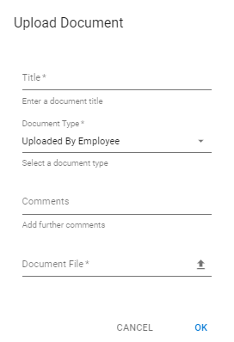

The file will now be listed under the My Documents screen.

Note: If you’d like to delete this file, this can only be done by your Local HR team.

