University Court

Head of College

Head of Institute

Principal Investigators

Institute Health & Safety Committee

Staff, students & visitors

Head of Administration

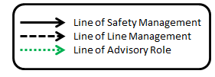

Head of Institute Dan Haydon

Head of Administration Christopher Bevan

Institute Health & Safety Committee Members

Lisa Ranford Cartwright Convener of Committee, Institute Safety Adviser & CL3 Lead

Anne Graham Safety Coordinator

Katarina Oravcova Bacteriology Lead

Brian Shiels Parasitology Lead

Neil Evans Physiology Lead

Martin Llewellyn Molecular Biology Lead

Kath Allan International Fieldwork Lead

Christopher Bevan Management Representative

Ana Monteiro Area Safety Lead HWC

Maria Capstick Area Safety Lead Gilmorehill

Nicol McCallum Area Safety Lead SCENE

Winifred Boner Committee Structure Bridge

Magdalene Papatheodoulou Student Representative

Courtney Melvin Clerk