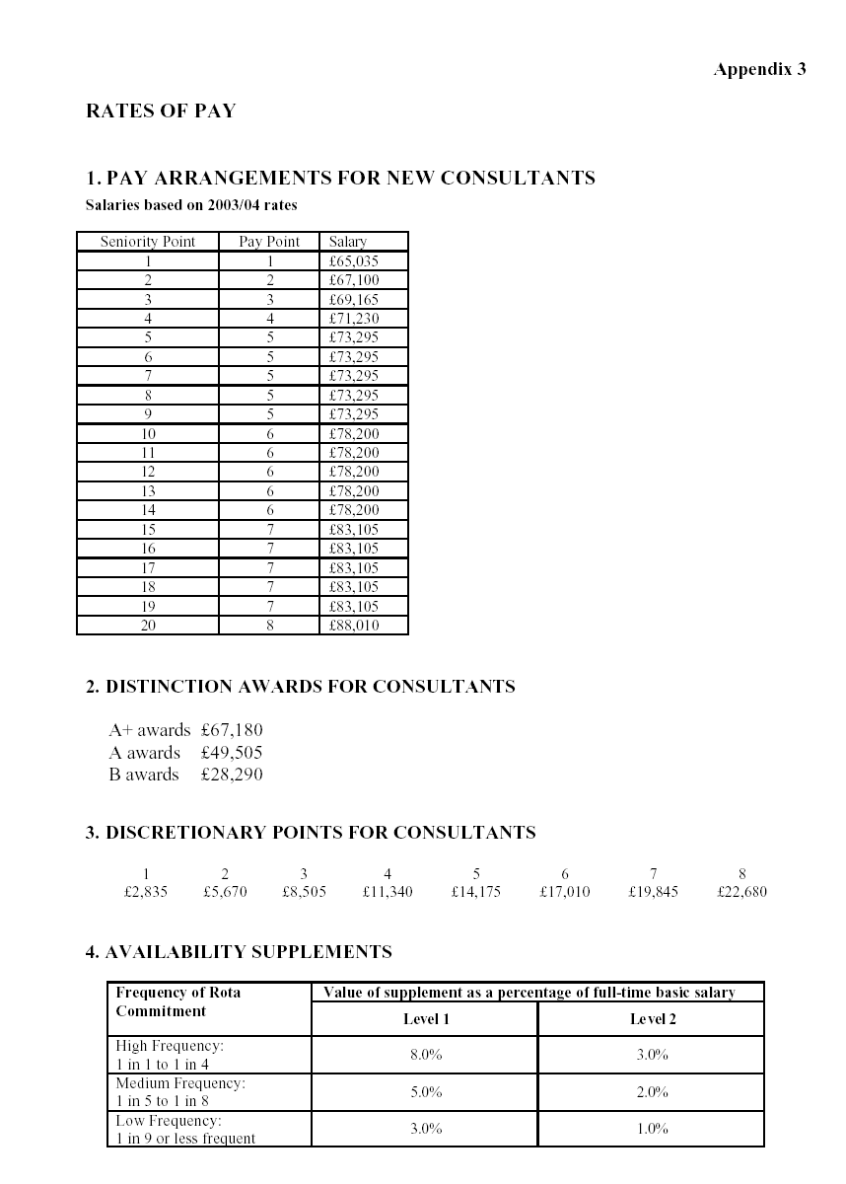
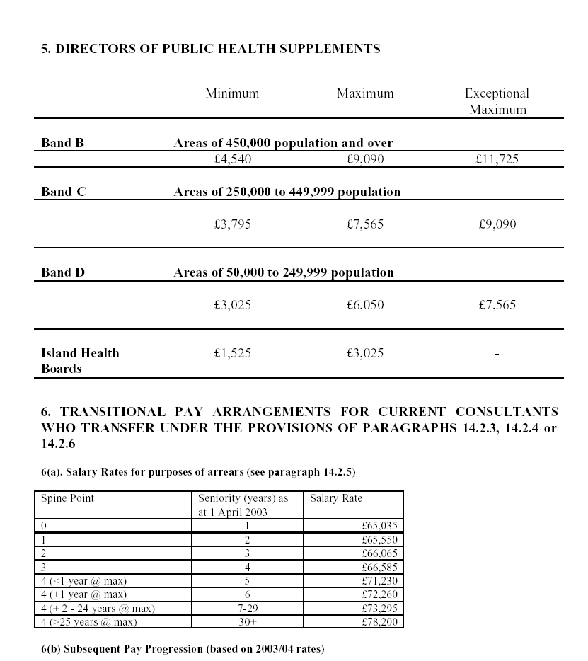
Seniority (years) as 1 April 2003 | University of Glasgow Grade Codes | Starting Salaries/ Interval (years) | Basic Salary
30+ | 911 | From 1 April 2004  1 | £83,105  £88,010
21-29 | 912 | From 1 April 2004  1  1 | £78,200  £83,105  £88,010
20 | 913 | From 1 April 2004  1  2 | £78,200  £83,105  £88,010
19 | 914 | From 1 April 2004  2  2 | £78,200  £83,105  £88,010
18 | 915 | From 1 April 2004  1  1  2 | £73,295  £78,200  £83,105  £88,010
17 | 916 | From 1 April 2004 | £73,295  £78,200  £83,105  £88,010
16 | 917 | From 1 April 2004  2  1  3 | £73,295  £78,200  £83,105  £88,010
15 | 918 | From 1 April 2004  2  1  4 | £73,295  £78,200  £83,105  £88,010
14 | 919 | From 1 April 2004  2  2  4 | £73,295  £78,200  £83,105  £88,010
13 | 920 | From 1 April 2004  2  2  5 | £73,295  £78,200  £83,105  £88,010
12 | 921 | From 1 April 2004  2  3  5 | £73,295  £78,200  £83,105  £88,010
11 | 922 | From 1 April 2004  3  3  5 | £73,295  £78,200  £83,105  £88,010
10 | 923 | From 1 April 2004  3  4  5 | £73,295  £78,200  £83,105  £88,010
9 | 924 | From 1 April 2004  3  5  5 | £73,295  £78,200  £83,105  £88,010
7-8 | 925 | From 1 April 2004  4  5  5 | £73,295  £78,200  £83,105  £88,010
6 | 926 | From 1 April 2004  4  5  5 | £73,295  £78,200  £83,105  £88,010
5 | 927 | From 1 April 2004  1  4  5  5 | £72,260  £73,295  £78,200  £83,105  £88,010
4 | 928 | From 1 April 2004  1  1  3  5  5 | £69,165  £71,230  £73,295  £78,200  £83,105  £88,010
3 | 929 | From 1 April 2004  1  1  4  5  5 | £68,130  £71,230  £73,295  £78,200  £83,105  £88,010
2 | 930 | From 1 April 2004  1  1  5  5  5 | £67,100  £71,230  £73,295  £78,200  £83,105  £88,010
1 | 931 | From 1 April 2004*  1  1  1  5  5  5 | £66,065  £69,165  £71,230  £73,295  £78,200  £83,105  £88,010
* (or anniversary of appointment if appointed after 1 April 2003)

