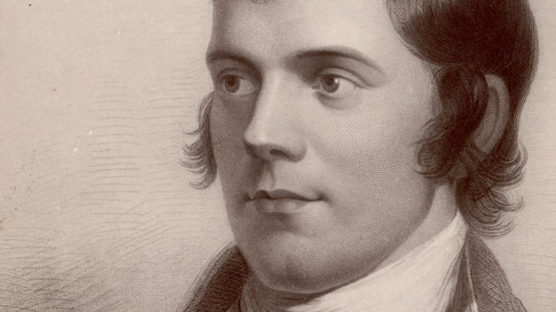
Robert Burns
1759-2009

A colloquium

University of California,
Berkeley

Friday, September 11, 2009

Join us for a one-day colloquium on the poetry of Robert Burns at the UC Berkeley Department of English -- part of a world-wide series of conferences, lectures, and other events marking the 250th anniversary of the poet’s birth.

Afternoon panels will feature leading scholars of Burns and eighteenth-century Scottish literature, including Leith Davis, Ian Duncan, Carol McGuirk, Steve Newman and Janet Sorensen. The evening keynote lecture will be given by Robert Crawford, Professor of English at the University of St. Andrews. One of Scotland’s leading poets and critics, Robert Crawford is the author of Scotland’s Books: A History of Scottish Literature (2008) and The Bard: Robert Burns, A Biography (2009).

The colloquium will take place in 300 Wheeler Hall, on the UC Berkeley campus, from 2:00–5:30 pm, followed by a reception and Robert Crawford’s lecture.

Robert Burns 1759-2009 is sponsored by the Center for British Studies, the Department of English, the Dean of Arts and Humanities, and the Doreen Townsend Center for the Humanities, University of California, Berkeley, and the Saint Andrew’s Society of San Francisco. For information contact
Ian Duncan iduncan@berkeley.edu or Janet Sorensen jsorensen@berkeley.edu.

