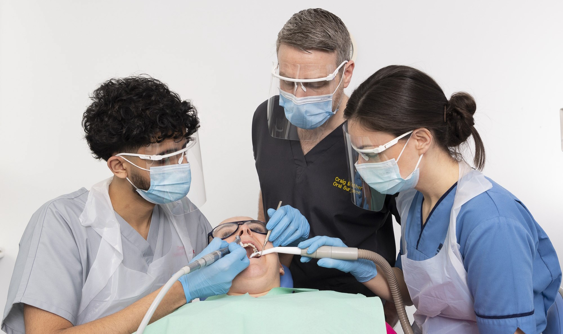

# Bachelor of Dental Surgery Undergraduate Degree Programme

**Person Specification**

**September 2025 Entry**

# [med-sch-dental-ug@glasgow.ac.uk](mailto:med-sch-dental-ug@glasgow.ac.uk)

**Academic Requirements**

### Essential—School students must apply from S6. Applications from S5 will not be considered.

**Highers/Advanced Highers**

AAAAB Higher + BB Advanced Higher (**MUST** be in Advanced Higher Biology **and** Chemistry)

(AAAAB S5 minimum for consideration)

* Interested parties should note that

the following outlines the academic qualifications and other requirements for applications to the BDS Pro-

gramme and should be read in con- junction with the information pub- lished on the website. The Dental School reserves the right to make

reasonable adjustments to the per- son specification at any time, as re- quired.

* The UCAT (University Clinical Apti- tude Test), is an essential compo- nents of applying.
* There are a range of personal charac- teristics important in the selection of prospective dental professionals;

these are detailed in this document, and assessed throughout our selec- tion process.

Additional requirements:

* + Higher Biology and Chemistry at grade A.
  + Higher Maths or Physics
  + National 5 English at grade B.

**S6**

3 subjects should be studied and **MUST** include:

* Advanced Higher Biology and Chemistry (**both** must be at grade B).

See prospectus for full details and adjusted Higher requirements.

To meet the academic criteria for interview, we will look at S5

results and expect applicants to have attained AAAAB. This must include Biology and/or Chemistry at Grade A as a minimum.

For adjusted requirements. Please see [https://www.gla.ac.uk/study/wp/](http://www.gla.ac.uk/study/wp/)

### A Levels

AAA in 3 different subjects by the end of Year 13 PLUS the GCSE

requirements. A Levels **MUST** be attained at the 1st sitting and include:

* Biology/Human Biology at Grade A
* Chemistry at Grade A
* GCSE—6 subjects at Grade A/7-9 **MUST** include:
  + Maths and/or Physics
  + English Language or English Literature (pass at Grade B/6 or above accepted provided the overall conditions are met).

**All grades must be achieved at one sitting (one year). This applies to all qualifications, from all countries and exam bodies. For details on our extenuating circumstances policy see** [**https://www.gla.ac.uk/schools/**](http://www.gla.ac.uk/schools/) **dental/undergraduate/academicentryrequirements/**

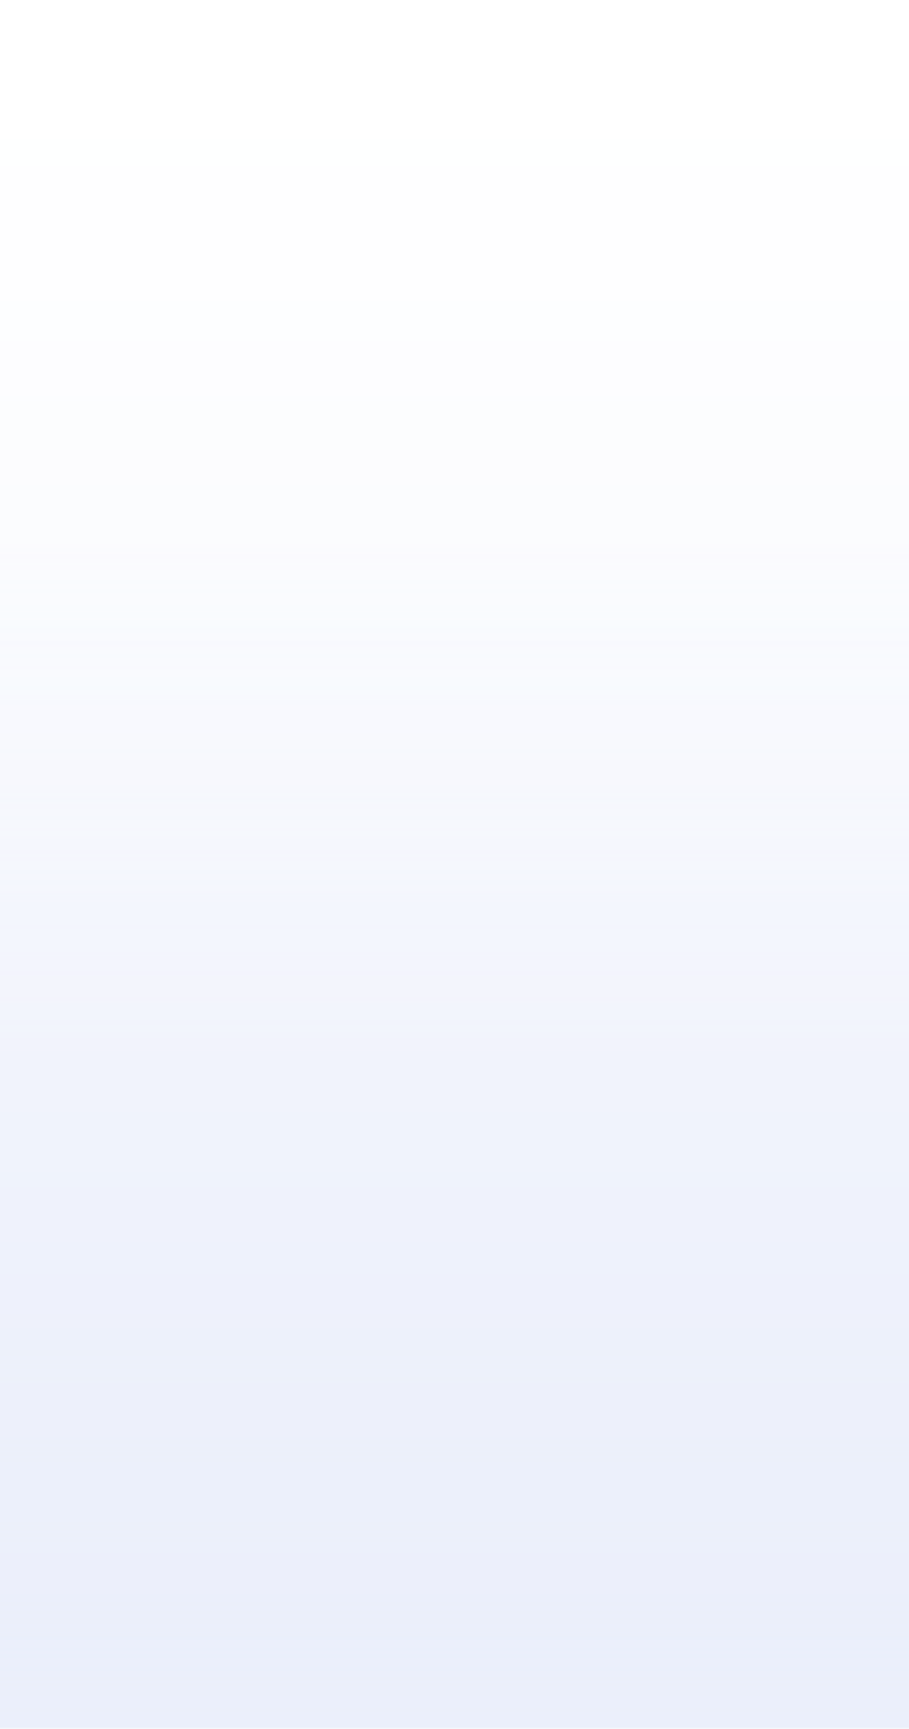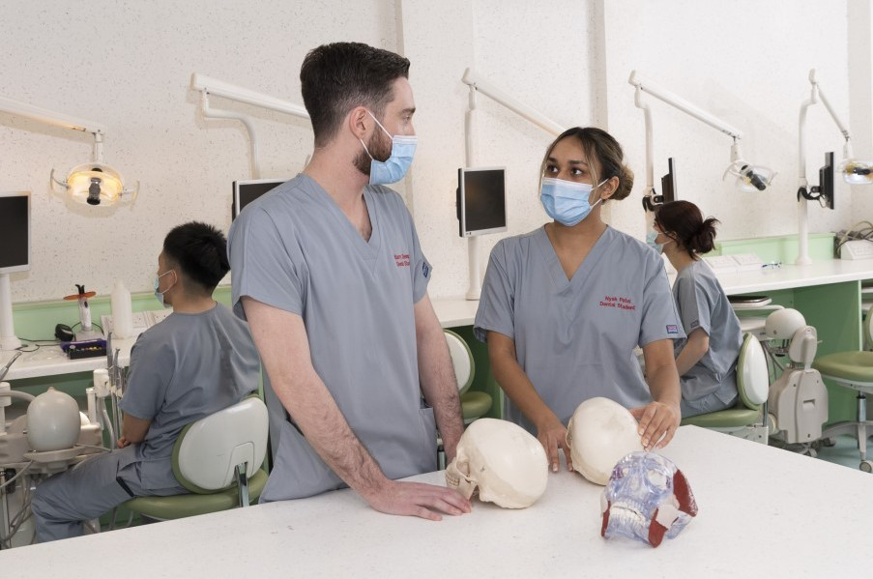

September 2025 Entry

**Please Note**

* We are unable to consider applica- tions based on re-taken examinations
* We are unable to consider transfer requests from students who have commenced a degree course at an-

other institution and not completed it. Likewise, we do not consider any

current degree students unless in the

final year of their Programme.

* Re-applicants to the Programme will be considered. Re-applicants must apply through the usual channels and take the UCAT test in the year of ap- plication.
* Our full Admissions Procedure can be found at https:/[/www.gla.ac.uk/](http://www.gla.ac.uk/)

media/Media_837954_smxx.pdf

### International Qualifications

All international qualifications are assessed by the UK ENIC guidelines to ensure that they are of the equivalent level of UK qualifications. In addi- tion, applicants whose first language is not English must provide proof of their English Language proficiency

[www.gla.ac.uk/international/englishlanguagerequirements/](http://www.gla.ac.uk/international/englishlanguagerequirements/)

### Graduates

Graduates will be considered provided they have attained the minimum

of a 2.1 **honours** degree in a relevant subject and can demonstrate the

equivalence of:

* Chemistry and Biology (equivalent to Grade A Higher, Grade A A level or better)
* Maths and/or Physics (equivalent to Grade A Higher, Grade A GCSE or better

Attainment of these qualifications can be evidenced through the degree transcript or from prior qualifications (within 6 years). Where any of the above have not been met, interested parties can achieve them as addi- tional qualifications prior to applying

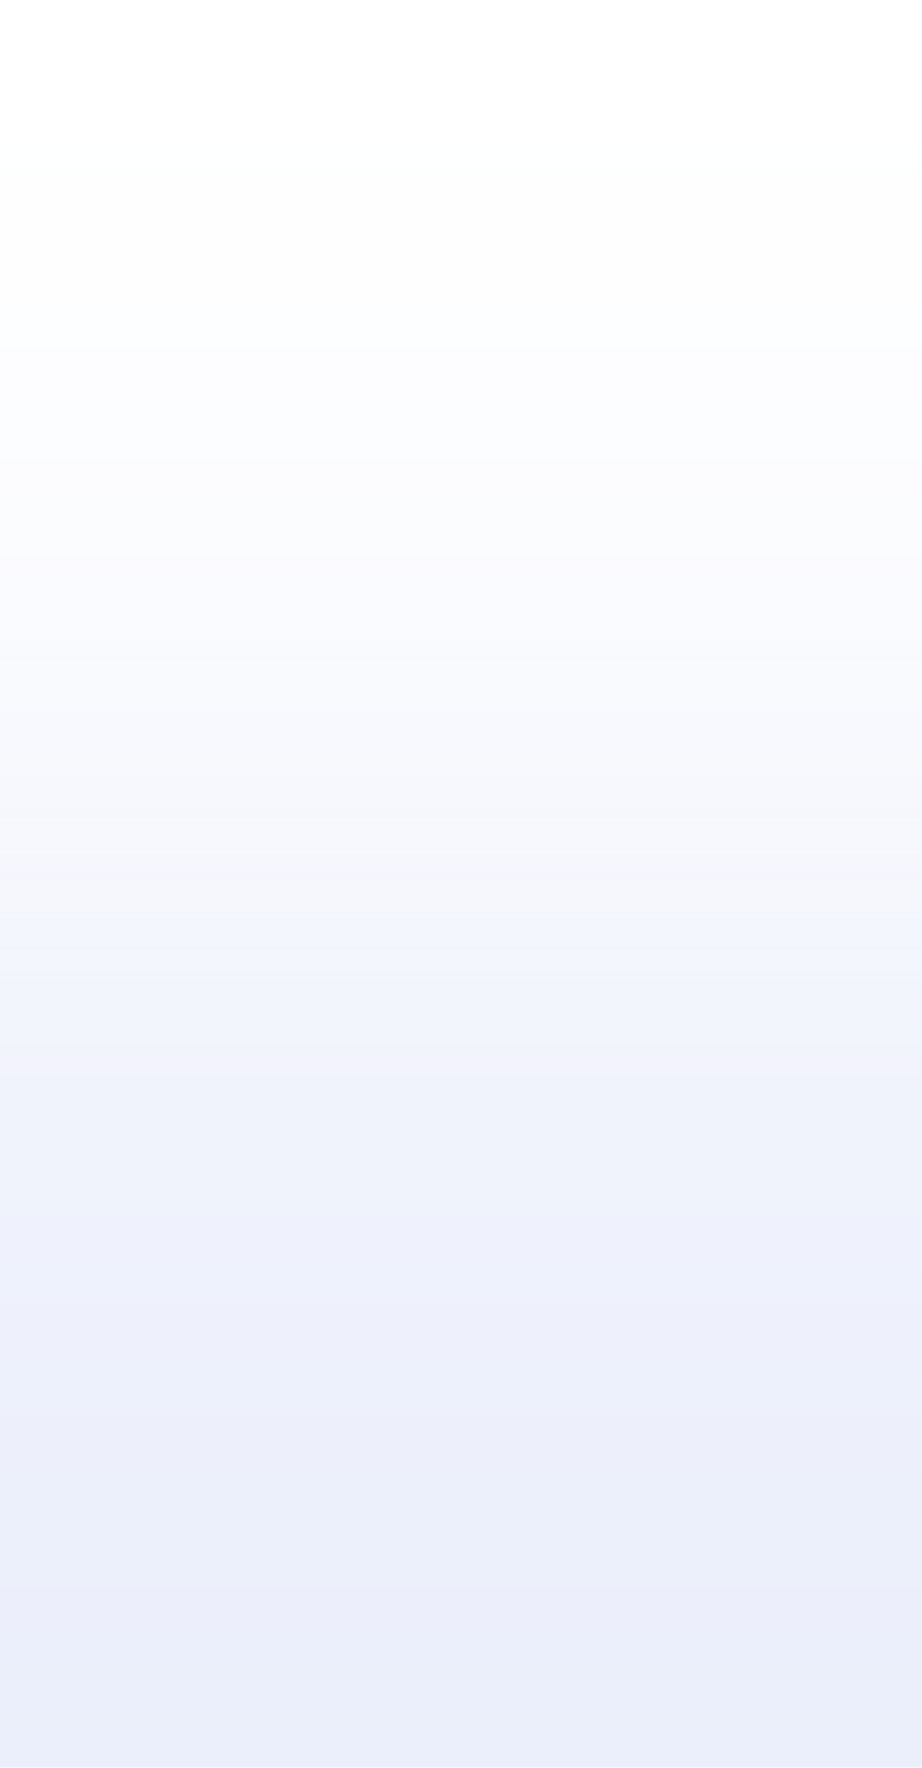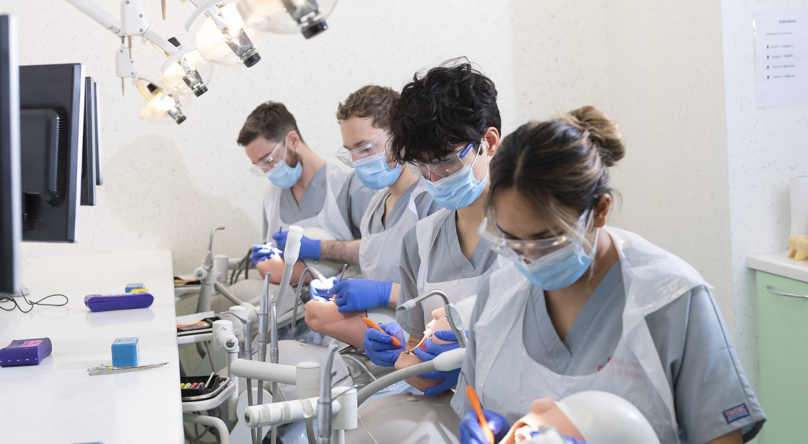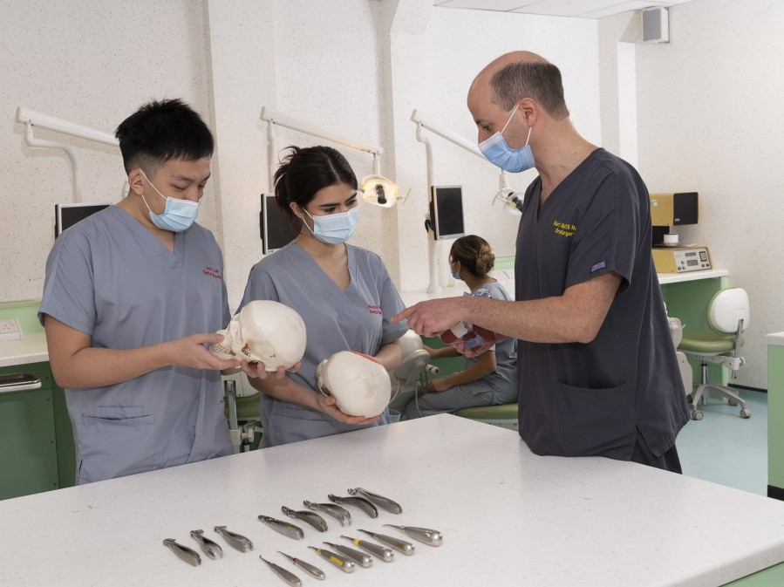

### Mature Applicants

Will be expected to demonstrate equivalent academic and extra-

curricular attainment to all other applicants. Updated qualifications in Biology, Chemistry and Maths or Physics may be obtained at FE Colleges or through an Approved Access to Medicine course. Please contact the admissions office for further information.

## September 2025 Entry

**UCAT**

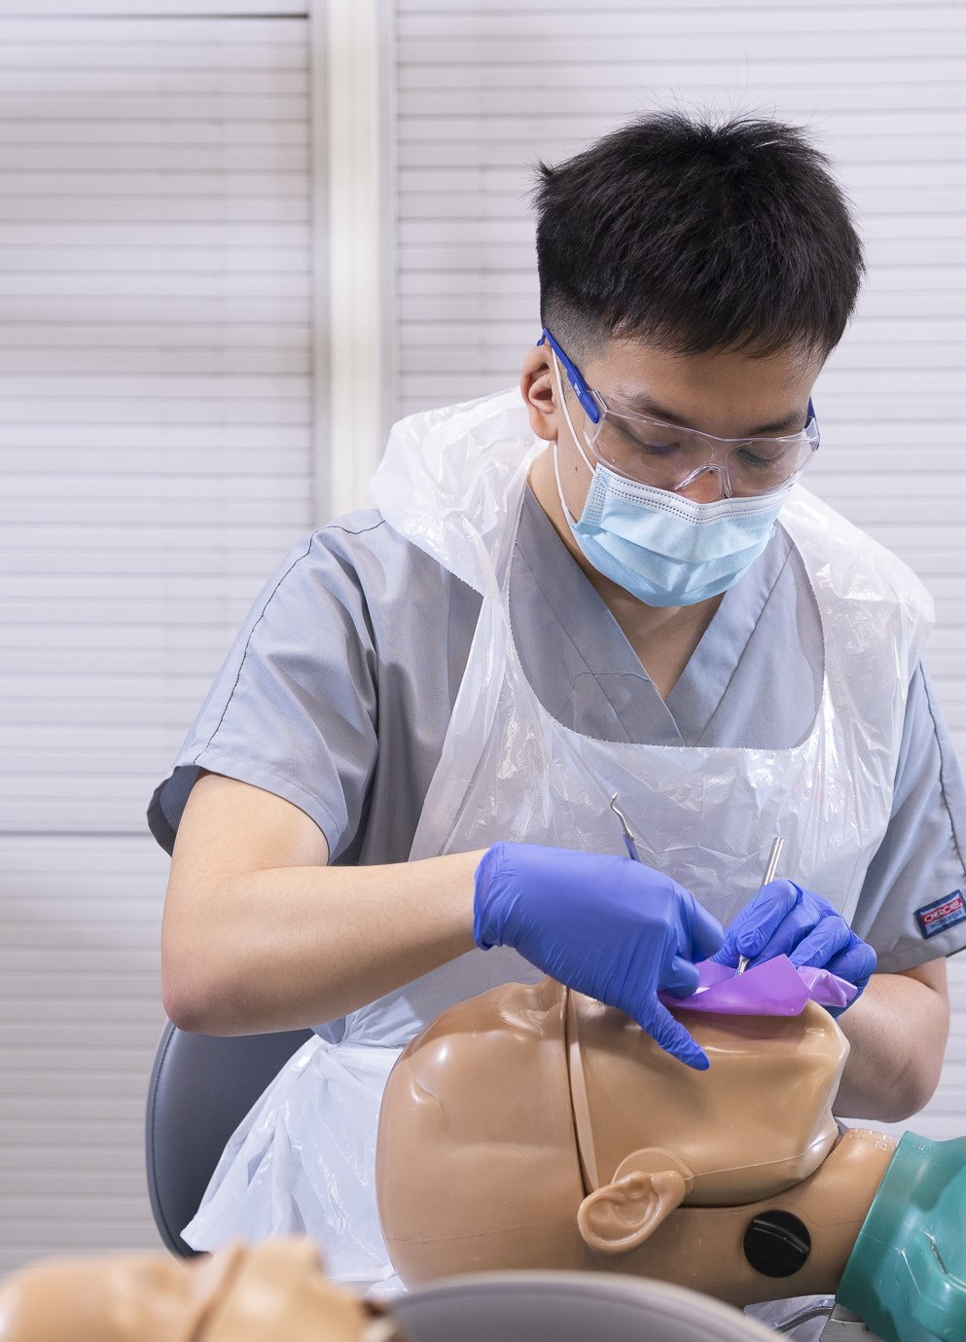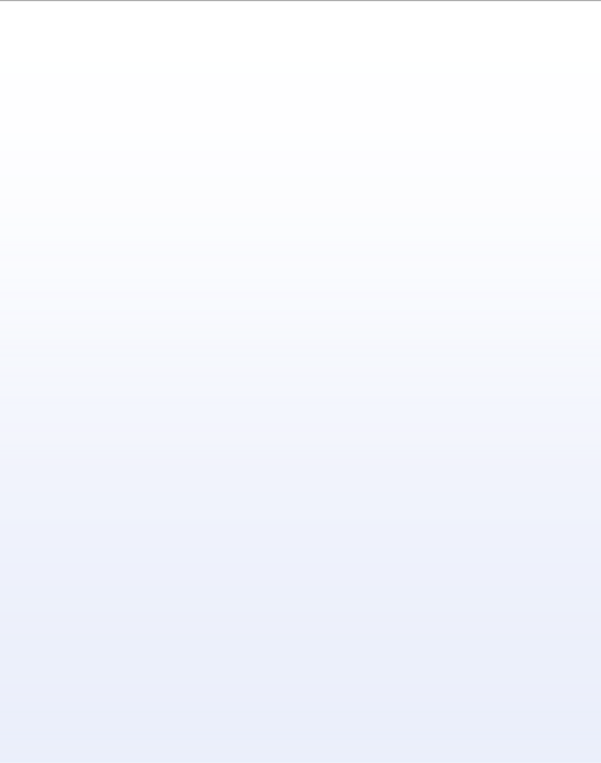

All applicants are required to undertake the UCAT test in the year of application, registration opens in June and closes in September. Applicants will be ranked on the basis of their

UCAT score and around 200 will be selected for interview.

The percentile cut off point varies from year to year, and

will normally be above the national average. We do not dis- close the score used in the year of application.

# Work Shadowing

We recognise that obtaining work shadowing in a dental setting is becoming increasingly difficult, however, appli-

cants may still be able to secure alternative forms of shad- owing or voluntary work which involves caring for and inter- acting with different people or develops the skills you will need as a dental professional

For more information on alternatives see https:// [www.gla.ac.uk/schools/dental/undergraduate/](http://www.gla.ac.uk/schools/dental/undergraduate/) workshadowing/

# Interviews

Applicants will be notified in December if they have been selected for interview.

**Important Characteristics**

Applicants also need to demonstrate characteristics which are important for the dental profession including being able to:

* Be diligent and ethical
* Demonstrate having a caring nature, are empathetic and respectful of the views of others
* Demonstrate good communication skills
* Work in a team and have the capacity to act as a leader
* Be self critical and self motivating
* Capable of independent thinking
* Plan and think on the spot and enjoy problem solving
* Show strong evidence of manual dexterity, creativity and spatial awareness Our interview process has been designed to test these characteristics.

## September 2025 Entry