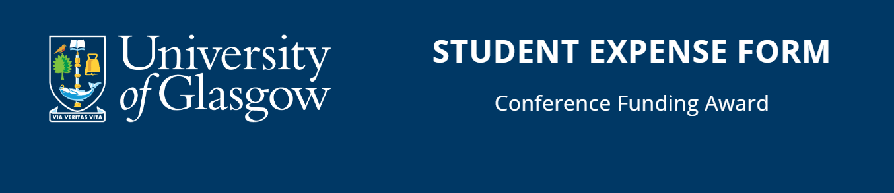
Return this completed form to mvls-gradschool@glasgow.ac.uk, within two months of the event, or by July 31st in the current academic year, whichever is soonest.
All expenses will be reimbursed to a project code, not a personal bank account.
Student Personal Details:
Name
ID
Email
Address
(Including full postcode)
Country
Event Attended
Date Attended
Amount claiming as stated in award letter

Project/Budget Code (to receive money via non-reversing journal):
Project code
Project code

Summarise your expenses below:
Food and drinks are not to be included. Adhoc expenses like train/metro/taxi/Uber/anything you can’t use a project code to pay for upfront, etc, will have to be claimed via the new student expense tile on your MyGlasgow Student Portal. The Graduate School will only reimburse the amount awarded as stated on your award letter.
Expense Type | Claim Amount (in GBP)
TOTAL

DECLARATION

I certify that this claim:

a) is to reimburse expenditure incurred by me on behalf of the University of Glasgow
b) has not & will not be met by any other outside source
c) should be paid to the project quoted above

Signature: Date:

PRINT NAME:

Return this completed form to: mvls-gradschool@glasgow.ac.uk

CHECKLIST:
Have you attached:
- Project code – Y/N
- Summary of expenses – Y/N
- Report – Y/N

